Design Brief - Prisma
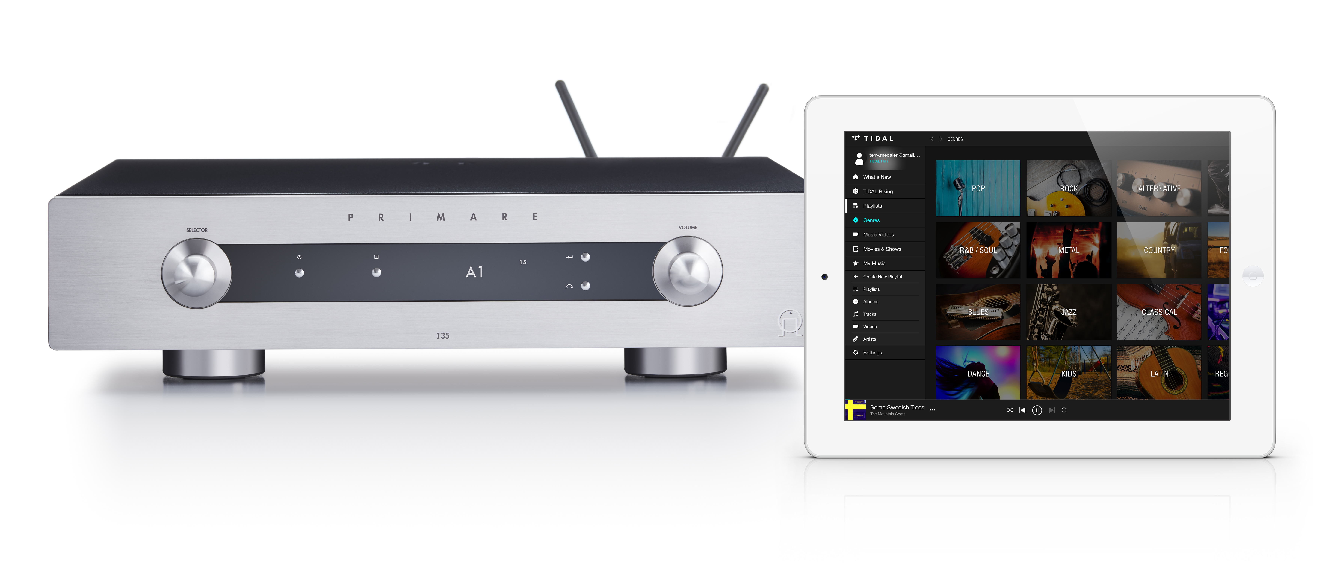

Prisma provides multi-room/multi-zone connectivity and control for playback of stored and streamed media, wired or wireless, all managed from any mobile device through a dedicated system Prisma control app. In addition to Bluetooth®, AirPlay, and Spotify Connect, Prisma features Chromecast built-in, a unique streaming portal allowing effortless direct connection to hundreds of streaming applications.

Contents
- Connectivity
  - Digital
  - Network
  - Streaming
- Control
  - Prisma application
  - Configuration
- Specifications

Connectivity
- Digital - USB-A
  - Sample rates up to PCM 24/192kHz and DSD128/5.6MHz
  - File formats: WAV, LPCM, AIFF, FLAC, ALAC, MP3, MP4 (AAC), WMA, OGG, DSD
- Network
- Wired/LAN – Ethernet connection for wired network system connection
- Wireless/WLAN - dual band wireless technology (WLAN IEEE 802.11 a/b/g/n and 802.11ac compliant)
- Streaming
- Bluetooth – connects Apple, Android, and Windows devices directly for playback of either streamed or stored content from the associated device with lossy compression. Given the wide availability of this technology and lower resolution capabilities, Bluetooth is an easy way to stream content for informal listening.
- AirPlay 2 – connects Apple devices over the WiFi network for playback of any streamed or stored content from the associated device with lossless compression. As a result, AirPlay has the capability of playing over greater distances than Bluetooth, and, as the Apple Lossless Audio Codec is used, to allow streaming quality up to CD quality (44.1kHz/1140kbps), is appropriate for more critical listening. Recent updates to iOS allow for playback of TIDAL HiFi Masters files for improved audio performance. AirPlay 2 further adds multi-room/multi-zone functionality within the AirPlay ecosystem.
- Spotify Connect – connects any device (mobile or PC) with the Spotify application directly to that service over the WiFi network and allows for playback at the highest level offered by the required Premium service (up to 320kbps).
Note: requires Spotify Premium account.
- Chromecast built-in - offering the greatest level of connectivity and control options, compatible with Apple, Android and Google devices:
  - The associated Google Home application connects the Prisma device to your WiFi network to allow the casting of hundreds of music streaming services.
  - Casting can be done from virtually any mobile device, as well as computers from the Chrome browser.
  - Chromecast built-in provides a direct connection between the Prisma device and the preferred music service through the network, therefore playback quality is limited (up to 24-bit/96kHz) only by the resolution provided by that service, meaning the possibility of higher resolution playback for critical listening from services like TIDAL HiFi and Qobuz.
  - Roon endpoint functionality allows for the use of Roon’s sophisticated digital music management software – see below.
  - Multi-room and multi-room connectivity and control:
    - More than one device can be connected at a time
    - Content can be cast to any Chromecast built-in device on the network
    - Control of all functions can be accomplished from anywhere within the network
  - Automatic Prisma firmware updating through Google Home application.
  - Voice control though the Google Home speakers and Google Assistant.
- Roon Ready –Roon transforms the experience of browsing music. Artist photos, credits, bios, reviews, lyrics, tour dates, and composers are located automatically, then interconnected by links to build a surfable, searchable digital magazine about your collection. Roon finds all the same links between your personal files and the millions of tracks available on TIDAL and Qobuz, so you can start with the music you know, then explore and discover new music from the world beyond your collection. In addition to music browsing, Roon is a multi-room, multi-user networked audio platform built to the exacting standards of audiophiles. It offers features like bit-perfect playback, DSD and PCM upsampling, multichannel playback, and signal path display. Roon plays to a number of different types of devices on your home network and can be controlled from Mac, Windows, iOS, and Android.
Note: Roon Ready functionality will be made available by future update on all Prisma models by the end of 2020.

Multi-room/Multi-zone
There are a number of options available with Prisma for multi-room/multi-zone configuration and control:
- AirPlay ecosystem: AirPlay 2 adds the ability to stream music from your Apple device to multiple speakers or devices across any number of rooms in your house. As long as everything is hooked to the same Wi-Fi network and supports AirPlay 2, you can stream across the devices.
Stream music, podcasts, and other audio to an Apple TV, HomePod, or AirPlay 2-compatible speaker or smart TV from your Apple device, be it an iPhone, iPad, Apple TV or Mac computer. Play audio across multiple speakers throughout your home in perfect sync. Or play something different in every room — all with AirPlay.
Note: AirPlay 2 available now with NP5 Prisma and available for all Prisma models by future software update.
- Chromecast eco-system: when playing any service available from Chromecast, the signal can be played over any Chromecast enabled device, including all Prisma models, controlled by the Google Home application. This would seem to provide the multi-room/multi-zone connectivity solution for the situation you describe, as long, of course, that the ancillary speakers are Chromecast enabled.
- Spotify Connect eco-system: setting all the speakers that you want to play as a group to Multi Mode, allows you to play music and select the group called 'MULTI' from the 'Devices Available' menu.
Note: requires Spotify Premium account.
- Prisma eco-system: when playing digital music files from a NAS (network connected hard drive) through the Prisma module, the signal can be sent to any other Prisma product connected to the network.
Note: we are working towards a future update that will allow any analog input to a Prisma integrated amplifier or preamplifier to be played back on any other Prisma product connected to the network.

Control
Not only does the Prisma application allow for input selection and CD player playback functions, but also complete NAS (network connected hard drive) control:
- Search by artist, album, track, and title from stored media
- Playlist and Queue creation from stored media
- Playback functions: Play, stop, track forward and back, shuffle play, repeat single or all tracks, volume mute, volume adjustment either by tapping the -/+ icons or sliding your finger across the volume bar
- Track information:
  - Playing from: indicates the source of the music file being played back
  - Path: indicates the path by which the music file is being accessed
  - Track duration: indicates elapsed and remaining time
  - Bitrate: indicates bit rate of the music file being played
  - Sample rate: indicates sample rate of the music file being played
  - Format: indicates format of the music file being played.

System configuration
Prisma allows for complete component configuration, including:
- Source settings – select media servers on your network to use
- Zone – manage zones to connect with Prisma devices in other areas of the house
- Input settings
  - Create Alias – edit the alias to give each input a specific name, for easier identification
  - Status – enable or disable the input to make it visible or not, so only those you use are visible for easier input selection
  - Auto-sense – enable auto-sense to determine which inputs will be automatically selected when a signal is detected
  - Volume – choose between variable or fixed volume, allowing any input to pass through the preamp stage to connect directly to the amplifier for use of within a home theater system configuration.
Or fixed gain setting allows for any input to be use in a theater or surround sound pass through configuration
  - Input Gain – adjusting the input gain so that all inputs to be at the same relative volume level, and as result the ability to raise or lower overall gain for preferred output volume setting
- Audio Settings
  - Balance – to adjust the output balance between the left and right speaker
  - Startup volume – sets the volume level at a predetermined level upon turn on from standby or at the level when last switched off.
  - Maximum volume – sets the maximum volume
  - Mute volume – sets the output level when muted, from 0 to any preferred setting
  - Digital volume – to select between 48kHz and 96kHz settings for the digital output from analog inputs, as some devices in your system might not be compatible with the default 96kHz output.
- General
  - Show inputs – choose between showing all enabled inputs or only those with signal
  - Front panel – to lock the front panel to disable all front panel controls
  - Auto dim – select the amount of time at which the front panel display will dim
  - LED brightness – set the level of display brightness for three specified dim levels
  - Standby settings
    - Auto-standby – sets the amount of time without user interface action or signal from last selected source before the device automatically goes into standby
    - Wake up – enables auto-sense to wake up the device to from standby upon detecting an input signal source
    - Factory reset – allows for the device to be returned to factory default settings
  - Streaming settings
    - Show metadata – enable or disable metadata appearing in OLED display when streaming
    - Bluetooth settings
      - Visible – enable or disable Prisma device being visible to Bluetooth devices
      - Auto-connect – enable or disable automatic connection with Bluetooth devices
    - Network Settings
- AirPlay password – set AirPlay password
Specifications

Key Features

- Hi-Res Audio
  - PCM up to 192KHz/24 bits
  - DSD up to 256/11.2MHZ, both native DSD and DSD over PCM (DoP)
- Advanced multi-zone audio streaming technology (DDMS)
- SPDIF Output
- 1x USB 2.0 OTG
- Ethernet LAN
- Wi-Fi 1x1 Dual Band (WLAN IEEE 802.11 a/b/g/n and 802.11ac compliant)
- 2x Antenna (5 GHz WLAN, 2.4GHz WLAN, and 2.4GHz BT)
- Bluetooth

General Specifications

Audio formats: WAVE, AIFF, FLAC, ALAC, MP3, MP4 (AAC), WMA, OGG, DSD

Frequency Response:
- Analog: 20Hz – 20kHz -0,5dB
- Digital:
  - 44.1kHz 20Hz – 20kHz +0.1/-0,6dB
  - 96kHz 20Hz – 20kHz +0.1 /-0,2dB
  - 192kHz 20Hz – 20kHz +/- 0.1dB

Inputs:
- USB-A: up to 192 kHz/24 bit; DSD 256/11.2MHz
- Airplay®
- Bluetooth®
- Chromecast built-in®
- Spotify Connect®
- UPnP/DLNA
- LAN:
- Up to 192 kHz/24 bit; DSD 128/5.6MHz
                - Data transfer rate: 10/100Mbit
- WLAN:
- Up to 192 kHz/24 bit; DSD 128/5.6MHz
- IEE 802.11 a/b/g/n/ac compliant; 2.4/5GHz; b, g, n mode
- Data transfer rate: maximum of physical layer rate of 390 Mbps
Detailed Specifications

Format | Extension | USB-A | Streaming
AAC  (LC/HEAAC) | .AAC | Up to 16/48kHz | Up to 16/48kHz
AIFF | .aif | Up to 24/192kHz | Up to 24/192kHz
ALAC | .m4a | Up to 24/192kHz | Up to 24/192kHz
AMR-NB | .amr | Up to 12.2/8kHz | Not supported
AMR-WB | .awb | Up to 23.85/16kHz | Not supported
DSD | .dsf | Up to 64/128 [2.8/5.6MHz] | Up to 64/128 [2.8/5.6MHz)
FLAC | .flac | Up to 24/192kHz | Up to 24/192kHz
MP3 | .mp3 | Up to 16/48kHz | Up to 16/48kHz
Vorbis | .ogg | Up to 24/192kHz | Up to 24/192kHz
WAV | .wav | Up to 24/192kHz | Up to 24/192kHz
Wma | .wma | Up to 24/192kHz | Up to 24/192kHz

Wi-Fi
- Standard: IEEE802.11a, IEEE802.11b, IEEE802.11g, IEEE802.11n, and IEEE802.11ac (draft compliant)
- Data Rate:
  - 802.11b : 11, 5.5, 2, 1 Mbps
  - 802.11g : 54, 48, 36, 24, 18, 12, 9, 6 Mbps
  - 802.11n : MCS 0 to 7 for HT20MHz MCS 0 to 7 for HT40MHz
  - 802.11ac : MCS 0 to 9 for HT20MHz MCS 0 to 9 for HT40MHz MCS 0 to 9 for HT80MHz
- Operation Channel
  - 2.4GHz
    - 11: (Ch. 1-11) – United States
    - 13: (Ch. 1-13) – Europe
    - 5.0 GHz
    - 21: (Ch. 36, 40, 44, 48, 52,…161, and 165) – USA
    - 19: (Ch. 36, 40, 44,…136, and 140) - Europe
- Security: WEP 64&128 bit, WPA, WPA-PSK, WPA2, WPA2-PSK, WPS, IEEE 802.1x, IEEE 802.11i

Bluetooth
- Sampling Rates:
  - 44.1 KHz, 48 KHz
  - Joint Stereo 32 KHz
- Coexistence Support:
  - Intelligent AFH (Advanced Frequency Hopping) – Channel Assessment
  - WLAN/Bluetooth Coexistence (BCA) Protocol Support

